**Lesson 7:**

**Path-based Origin-Destination Demand Matrix Estimation (ODME) using STALite: Model, Workflow and Users Guide**

1. **Introduction**

This document aims to offer users to understand and further apply OD demand estimation. The algorithm is implemented in STALite, based on a simplified version of single-level nonlinear optimization model proposed by Lu, Zhou and Zhang (2013). This (static) path flow estimation model has the following key features.

1. The model is a **path flow-based optimization** model, which incorporates heterogeneous sources of traffic measurements and does not require building an external optimization program with the explicit link-path incidence matrix.
2. The **objective** is to minimize (i) the deviation between observed and estimated traffic flow, (ii) the deviation between aggregated path flows and target OD flows, and (iii) the deviation between observed and estimated production and attractions at the zone level, subject to nonnegative flow constraints.
3. This algorithm integrates a **gradient-projection-based path flow adjustment** method within a column generation-based framework.

**Reference:** Lu C-C, Zhou*, X. Zhang, K. (2013) Dynamic Origin-Destination Demand Flow Estimation under Congested Traffic Conditions. *Transportation Research Part C.* 34, 16-37.

1. **Mathematical model and solution algorithm**

Given sensor data (i.e. observed link flows), zonal production and attraction, and target (aggregated historical) OD demands, the proposed single-level path flow estimation model is a nonlinear program with the path flows ***r*** *=*{*r*(*w*, *p*), ∀*w*, *p*} as the decision variables.

The objective funciton, Eq.(1), minimizes the weighted sum of the deviation between estimated OD demands (or aggregated path flows) and target demands, the deviation between estimated and observed link flows, and the deviation between observed and estimated productions and attractions at the zone level, where *βr*, *βq*, *βo* and *βd* are the weights reflecting different degrees of confidence on target OD demands and observed link flows and zonal production and attractions, respectively. Eq.(2) represents nonnegative constraints of estimated path flows.

**P1: Nonlinear program**

Min $Z=β_{r}\sum_{w∈W}{{\left[\sum_{pP}{r\left(w, p\right)-}\overline{d}(w)\right]}^{2}}+β_{q}\sum_{lA}{{\left[q\left(l\right)-\overline{q}(l)\right]}^{2}}+β_{o}\sum_{iI}{{\left[O(i)-\overline{O}(i) \right]}^{2}}+β_{d}\sum_{jJ}{{\left[D(j)-\overline{D}(j)\right]}^{2}}$ (1)

Subject to

*r*(*w*, *p*) ≥ 0, ∀*w*, *p*. (2)

**where**

**Set:**

*A*: set of links

*W*: set of OD pairs

*P*: set of paths

*S*: set of links with sensors, *S* ⊆ *A*

*I*: set of origin zones

*J*: set of destination zones

**Index:**

*w*: index of OD pairs, *w*∈*W*

*p*: index of paths for each OD pair, *p*∈*P*

*l*: index of links, *l*∈*A*

*i*: index of origin zones, *i*∈*I*

*j*: index of destination zones, *j*∈*J*

**Indicator Parameters (given from column generation stage):**

$θ_{w,p}^{l}$: equals 1 if link *l* is on path *p* between OD pair *w*; 0 otherwise

$μ_{w,p}^{i}$: equals 1 if zone *i* is the origin of OD pair *w*; 0 otherwise

$λ_{w,p}^{j}$: equals 1 if zone *j* is the destination of OD pair *w*; 0 otherwise

**Traffic measurements inputs**

$\overline{q}(l)$: observed number of vehicles passing through link *l*

$\overline{d}(w)$: target demand, which is the total traffic demand for OD pair *w* over a planning horizon

$\overline{O}(i)$: observed generation rate of origin zone $i$

$\overline{D}(j)$: observed attraction rate of destination zone $j$

**Estimation variables**

*r*(*w*, *p*): estimated path flow on path *p* of OD pair *w*

*q*(*l*): estimated number of vehicles passing through link *l*

*d*(*w*): estimated demand of OD pair *w*

*O*(*i*) : estimated generation rate of origin zone $i$

$D(j)$:estimated attraction rate of destination zone $j$

**Solution algorithm**

To solve the restricted master problem, a gradient-projection-based descent direction method (Lu et al., 2009) is used to update path flows ***r***(*m*+1), while maintaining the feasibility of non-negativity constraints Eq.(2). Specifically,

${r\left(w,p\right)}^{m+1}=Max\left\{0,{r\left(w,p\right)}^{m}-α^{\left(m\right)}\left[β_{r}∇h^{r}\left(r\right)+β_{q}∇h^{q}\left(r\right)+β_{o}∇h^{o}\left(r\right)+β_{d}∇h^{d}\left(r\right)\right]\right\}$ (3)

where  (*m*) is the step size, and the gradients, which consist of the first-order partial derivatives with respect to a path flow variable *r*(*w*,*p*), $r_{\left(w,τ,p\right)}$ can be derived as follows.

$∇h^{r}\left(r\right)=\frac{∂{\left[\sum_{pP}{r\left(w, p\right)-}\overline{d}(w)\right]}^{2}}{∂r(w,p)}=2\left(\sum_{pP}{r\left(w, p\right)-}\overline{d}(w)\right)$ (4)

$∇h^{q}\left(r\right)=\frac{∂\sum_{lA}{{\left[q\left(l\right)-\overline{q}(l)\right]}^{2}}}{∂r(w,p)}=2\sum_{lA}{\left\{\left[q\left(l\right)-\overline{q}(l)\right]×\frac{∂q\left(l\right)}{∂r(w,p)}×θ_{w,p}^{l}\right\}}$ (5)

$∇h^{o}\left(r\right)=\frac{∂\sum_{iI}{{\left[O(i)-\overline{O}(i) \right]}^{2}}}{∂r(w,p)}=2\sum_{iI}{\left\{\left[O(i)-\overline{O}(i)\right]×\frac{∂O(i)}{∂r(w,p)}×μ_{w,p}^{i}\right\}}$ (6)

$∇h^{d}\left(r\right)=\frac{∂\sum_{jJ}{{\left[D(j)-\overline{D}(j)\right]}^{2}}}{∂r(w,p)}=2\sum_{jJ}{\left\{\left[D(j)-\overline{D}(j)\right]×\frac{∂D(j)}{∂r(w,p)}×λ_{w,p}^{j}\right\}}$ (7)

Estimated path flows, link flows, zonal production and zonal attraction and the corresponding partial derivatives, namely $∇h^{r}\left(r\right)$, $∇h^{q}\left(r\right)$, $∇h^{o}\left(r\right)$ and $∇h^{d}\left(r\right)$ are obtained from the restricted master problem model P1.

The steps of this algorithm are presented as the following two major phases: column generation and column updating.

**Algorithm 1: Column based-solution algorithm**



Figure 1. Column based-solution flowchart

Solving the proposed single-level dynamic OD estimation model requires the evaluation of the partial derivatives with respect to path flows, i.e., $\frac{∂q\left(l\right)\left(r\right)}{∂r(w,p)}$, $\frac{∂O(i)\left(r\right)}{∂r(w,p)}$,, and $\frac{∂D(j)\left(r\right)}{∂r(w,p)}$.

**3. Users guide and workflow**

This section takes the following two-corridor network as an example. Shown in Figure 1, the two-corridor network has 4 nodes, 4 links and 1 OD pair (i.e., from node 1 to node 4). According to historical demand data and additional survey updates, the seed demand is set as 15000. The first path uses links 1-3 and 3-4 and the second one uses links 1-2 and 2-4.



Figure 2. Two-corridor network

**Step 1: Set parameters in file settings.csv**

The settings.csv file is used to define parameters for conducting traffic analysis. Table 1 lists important data fields for ODME with the corresponding values for one case. Specifically, there are three parameters:

1. Assignment_mode = odme.
2. The number_of_iterations defines the iteration number in stage A, i.e., the generation of a priori column pool.
3. The column_updating_iterations defines the iteration number in stage B, namely path flow estimation.

Table 1. Related attributes in file settings.csv for ODME

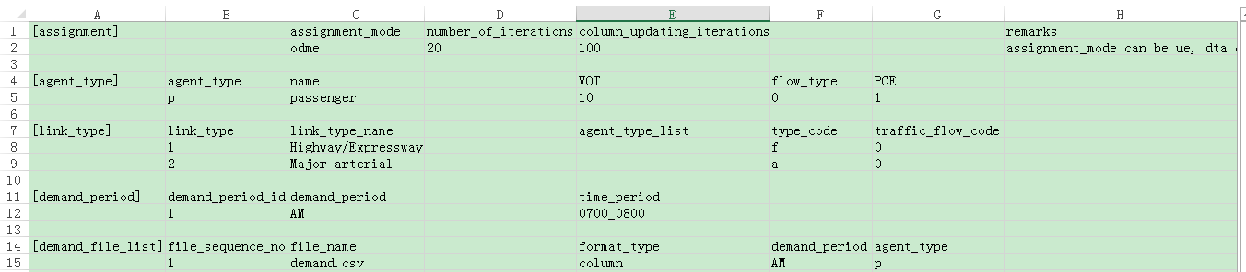

**Step 2: Prepare sensor data in measurement.csv file and set up the seed OD demand file for ODME**

Different types of sensor data for ODME are recorded in file measurement.csv, as listed in Table 2. The second row records an observed total production rate of zone 1, $\overline{O}\left(1\right)=8000$. The third row represents an observed attraction rate of zone 4, $\overline{D}\left(4\right)=4000$. The historical OD demand is listed in the fourth row, $\overline{d}\left(1\right)=5000$. It should be noted that, the historical OD demand as the measurements could be different from the seed demand. We typically use a higher demand level in the seed demand so as to generate a sufficient number of columns under congested conditions. The last two rows are observed link counts on link 1-3 and link 1-4, respectively.

Table 2. Required fields in measurement.csv, two-corridor test example.

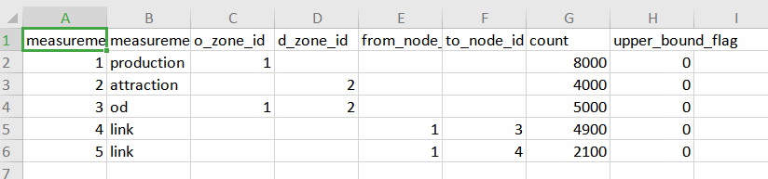

Remarks:

The field of upper_bound_flag aims to penalize the positive deviation, with respect to the measured traffic flow.

Table 3 lists three fields for the seed demand in demand.csv.

Table 3. Required data in demand.csv



**Step 3: Run STALite.exe**

**Step 4: Check the estimation results in agent.csv and link_performance.csv**

As shown in Table 4, two available paths have been generated from the first stage with the updated values from the second updating stage.

Table 4. Estimation results in agent.csv



Table 5. Estimation results in link_performance.csv

**Currently, the file link_performance.csv is empty.**

**Step 5: Check the deviations between the starting and final OD demand matrix in file output_ODME_table.csv (to do)**

This file is used to compare the final ODME result and the baseline OD demand table. Table 4 lists part of the results in two-corridor case.

Table 6. Part of the results in two-corridor case

|  |  |  |  |  |  |
| --- | --- | --- | --- | --- | --- |
| **o_zone** | **d_zone** | **hist_ value** | **updated_ value** | **difference** | **%_difference** |
| 1 | 3 | 7 | 7 | 0 | 0 |
| 1 | 3 | 8 | 8 | 0 | 0 |
| 1 | 3 | 8 | 8 | 0 | 0 |
| 1 | 3 | 7 | 7 | 0 | 0 |
| 1 | 3 | 8 | 9.75 | 1.75 | 21.9 |
| 1 | 3 | 8 | 9.23 | 1.23 | 15.3 |
| 1 | 3 | 8 | 9.75 | 1.75 | 21.9 |
| 1 | 3 | 7 | 8.2 | 1.2 | 17.1 |
| 1 | 9 | 16 | 15.1 | -0.9 | -5.6 |
| 1 | 9 | 17 | 16.97 | -0.03 | -0.2 |

**4. Sensitivity analysis**

This section examines the estimation results of the proposed algorithm on the above two-corridor network shown in Figure 2. As step 0, we use the UE assignment results as the benchmark to validate the estimation accuracy of STAlite, under different data availability and conditions.

**Step 0: Ground truth case**

In this the ground truth case, we load a total demand of 8,000 vehicles/hour to those two paths as shown in Table 7, with 30 UE iterations in Table 8, and with the field of assignment_mode being set as ‘ue’. The resulting UE assignment results are shown in Table 9, indicating that the equilibrium flow pattern and travel time on each path.

Table 7. Required data in demand.csv

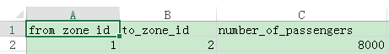

Table 8. Required fields in settings.csv

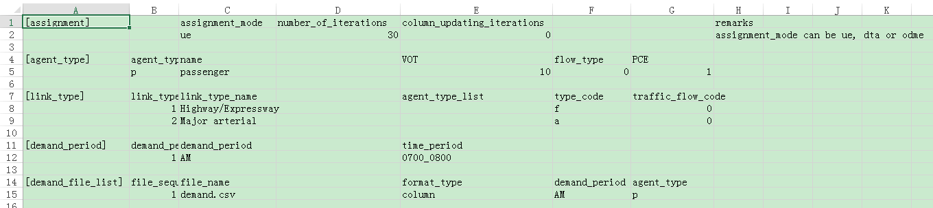

Table 9. User equilibrium traffic assignment results on the two-corridor network

|  |  |  |  |  |
| --- | --- | --- | --- | --- |
| Path | FFTT(min) | Capacity(veh/h) | Assigned flow(veh/h) | Travel time(min) |
| 1-3-2 | 44.4 | 4000 | 5067 | 61.5 |
| 1-4-2 | 54.4 | 3000 | 2933 | 61.8 |

**Step 1: ODME case**

We consider the error-free flow counts (the first path is 5067 and the second one is 2933), as shown in the last three rows in Table 10.

Table 10. Required fields in measurement.csv

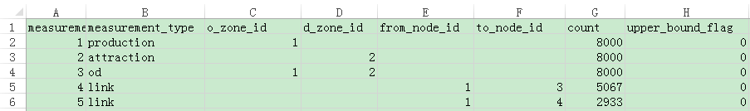

With a dramatically different demand seed in demand.csv.

Table 11. Required data in demand.csv



As shown in Table 12, the field of assignment_mode is set as ‘odme’ representing OD matrix estimation. The number of iteration is set 30 and the column updating iterations is set 100.

Table 12. Related attributes in file settings.csv

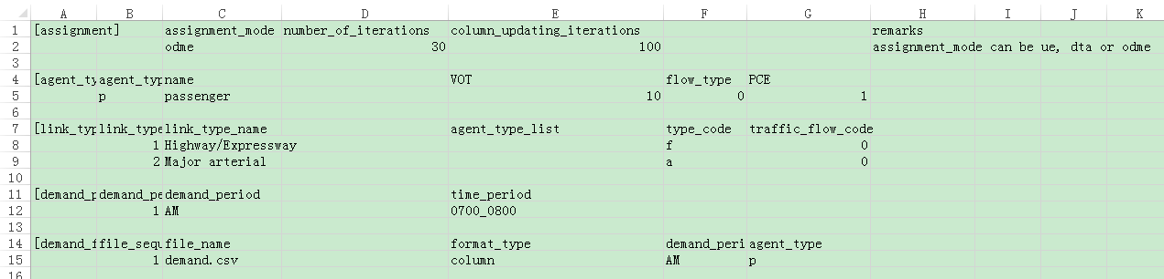

Table 13 lists the comparison between the ground truth case and the ODME solution. As we can see, the estimated demand is eventually adjusted to a level very close to the ground-truth demand, and the errors of path flow distribution and path travel times between these two solutions are reduced to insignificant values.

Table 13. Comparison between ground truth case and ODME solution

|  |  |  |  |  |  |  |
| --- | --- | --- | --- | --- | --- | --- |
| Path | Assigned flow(veh/h) in ground truth case | Assigned flow(veh/h) in ODME solution | Error | Travel time(min) in ground truth case | Travel time(min) in ODME solution | Error |
| 1-3-2 | 5067 | 5069 | 0% | 61.5 | 61.6 | 0% |
| 1-4-2 | 2933 | 2931 | 0% | 61.8 | 61.8 | 0% |